**Microsoft Azure Importance**

**BLP sessions:**

1) [Blended Learning Program - AZ 900 Microsoft Azure Fundamentals Kick off Session_ 2nd May 2023 from 3_30 pm to 4_30 pm - 23041066NBTechNext.-20230502_152049-Meeting Recording.mp4](https://capgemini-my.sharepoint.com/:v:/p/amit_sali/EVJmOqlGaHRKtO2ZJpBmwFwBJeVQFx565WKIkcRVJvK0Pw)

2) [Blended Learning Program - AZ 900 Microsoft Azure Fundamentals Touch Point 1_ 5th May 2023 from 9_00 am to 3_00 pm - 23041066NBTechNext.-20230505_091108-Meeting Recording.mp4](https://capgemini-my.sharepoint.com/:v:/p/amit_sali/EQ8XVA8jMXZPt8iV8I0g0woBCaEsHzUQeHnAwm_GEm3Nkw)

3) [Blended Learning Program - AZ 900 Microsoft Azure Fundamentals Touch Point 2_ 8th May 2023 from 9_00 am to 3_00 pm - 23041066NBTechNext.-20230508_090609-Meeting Recording.mp4](https://capgemini-my.sharepoint.com/:v:/p/amit_sali/EbZOkSeCcRJNrEMxYRagbfYBsC4BLc-T1sLhL7aDFyU-7g)

4) [Blended Learning Program - AZ 900 Microsoft Azure Fundamentals Touch Point 3_ 9th May 2023 from 9_00 am to 1_00 pm - 23041066NBTechNext.-20230509_091134-Meeting Recording.mp4](https://capgemini-my.sharepoint.com/:v:/p/amit_sali/EX6A-4BsYspPvKK0-aEr6zoBl-YhOdC76lJpObdotWRBZQ)

**Azure Certifications Learning Plan**: <https://degreed.com/plan/2849304>

**Microsoft Dynamics 365 certifications Learning Plan**: <https://degreed.com/plan/1243830#/>

<https://learn.microsoft.com/en-us/certifications/exams/az-900/>

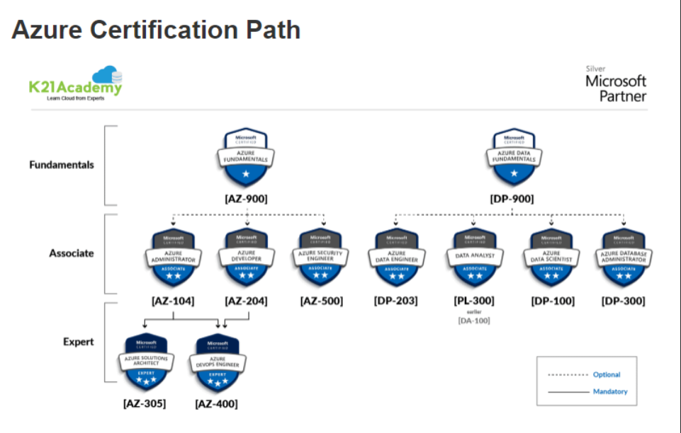

1. **What is cloud computing**

Cloud computing is the delivery of computing services over the internet. Computing services include common IT infrastructure such as virtual machines, storage, databases, and networking.

1. **Define cloud model:**

* Public
* Private
* Hybrid

1. **Advantages of Azure cloud:**

* Scalability
* Reliability
* Governance and compliance
* Flexibility
* Cost saving

1. **Disadvantages of Azure cloud:**

* For the public cloud data is on public domain
* Security
* Internet

1. **Disadvantages of private cloud:**

* High capital investment
* Less scalability

1. **Hybrid cloud:** Hybrid cloud is a cloud where most of the things is present into the private cloud only but few things as per requirement we can put into the public cloud.
2. **Which services is given to azure for public domain:**
3. **Information as a service (Iaas):**

* Storage service
* Virtual machine/compute capacity

(I need a complete control of an operating system, then I can go through Iaas)

1. **Platform as a service (paas):**

A platform is a combination of hardware + operating system and + application development software

(I'm ok with the operating system I want to do very small pix to the configuration then I can go for the paas)

**Example**:

intel i5 + windows10 + ide is one platform.

Sensolaric + Linux + anyide is another platform.

Mac machine + iOS + anyide is one more platform.

Mobile + android is one more platform

1. **Software as a service (saas):**

Saas means the final application, what are infrastructure using the background we don't care and how much data is consume we don't know.

Example: Outlook, teams, Microsoft office 365 etc.

1. **Multi-cloud**:

* Geus decide to go for AZURE
* Geuk decide to go for AWS

But at some point, of time decide to transfer the data to cloud 1, they decide to merge the cloud, decide to have a communicating the cloud in this scenario I’m in trouble, because 2 different vendors 2 different stories are not good , so that's why it is multi cloud environment, because one vendor can go through 2 different cloud providers**.** Because of this solution is **Azure arc**.

1. **Azure arc:**

Azure arc is a tool which is help us to manage the multicloud environment, multicloud environment can get manage with the service provided by azure arc.

1. **Azure VMware solution:(Virtual manager)**

* It is a tool which will help us to go virtualize the entire past level.
* Help us to create the virtual machine
* Help us to configure the virtual machine

1. **High availability:**

When we are deploying an application, a service, or any IT resources, azure is giving a highly available cloud environment with uptime guarantees depending on the service. These guarantees are part of service level agreement (SLAs).

**How they maintain:** They maintain the 3copies of our data that means if one goes down the 2nd copy is available the 2nd goes down 3rd copy is available. That 3 copies are not present in same location, present on the different locations.

1. **Scalability:**

Scalability refers to the ability to adjust resources to meet demand

1. **Vertical scaling:**

If we are developing an app and we needed more processing power, we could vertically scale up to add more CPUs or RAM to virtual machine. Conversely, if we realized you had over-specified the needs, we could vertically scale down by lowering the CPU or RAM specifications.

1. **Horizontal scaling:**

We could add additional virtual machines or containers, scaling out. In the same manner, if there was a significant drop in demand, Benefits of the reliability and predictability:

**Reliability:**

It means coming up or recovering from failure, so reliability is doesn't talk about the avoiding of the failure, if failure can occur with in how much time I’m recovering

**Predictability:**

Predictable performance and cost when we purchase a certain hardware, I can predict the performance that will gives and I can predict the cost which is getting use.

1. **Pricing calculator:**

It is a utility, or a tool provided by an azure to us. This tool will help for calculating the price.

1. **Describe the benefits of security and governance in the cloud:**

Security is provided by many ways like virtual private cloud we can create on that cloud we can put internet gateway,